**Introduction:**

Created container cards for the current Indian Team Players. It has three items

1. Player Name
2. Indian Team Logo and
3. Player image.

User has option to open, print or delete selected card.

To run the build code:

1. Open command line and go the build path (index.html) path.
2. Run **http-server**

To run the application kindly follow below steps:

1. Open command line and go to the project path (package.json) path.
2. Run **npm install**
3. Run **npm start**

Kindly note that npm install may take some time (5-10 minutes) to install all the dependencies.

Below are some screen shots from the application:

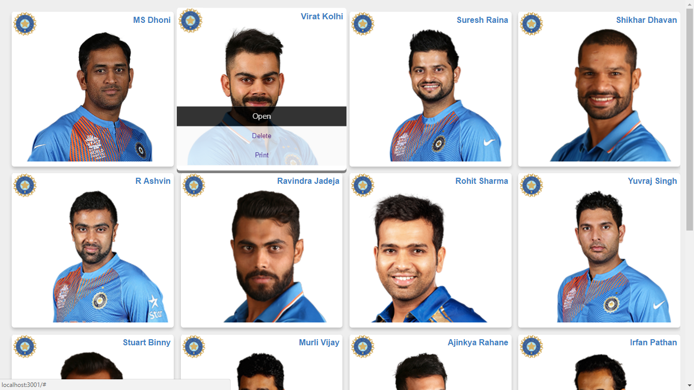

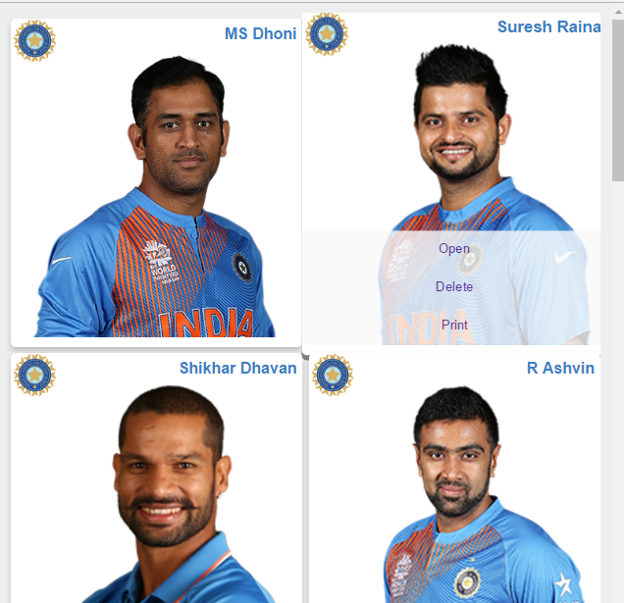

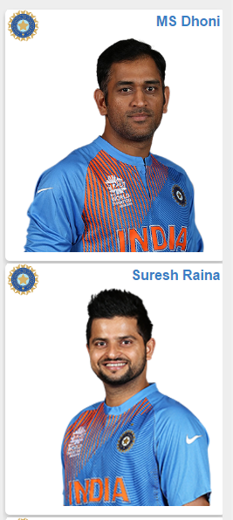

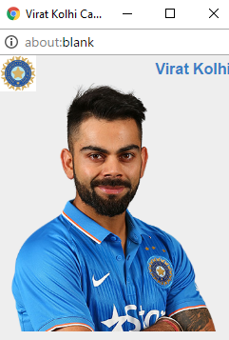

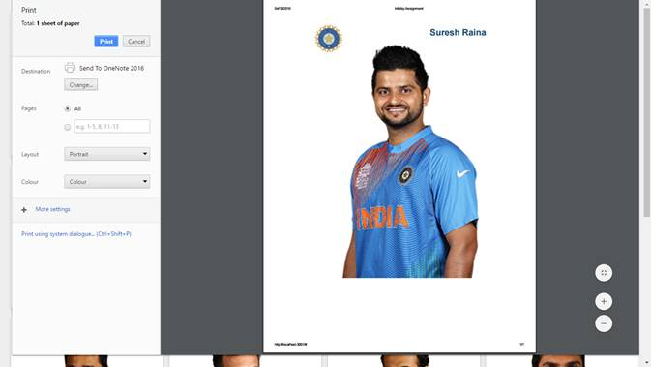

Reference Link:

<https://facebook.github.io/react/blog/2016/07/22/create-apps-with-no-configuration.html>